TFT800480-23-E
APPLICATION NOTE

This application note is only for reference and maybe changed without any notice .
Please contact TRULY R&D department for update files and product status before design for this product or release the order.

WRITTEN BY | APPROVED BY
HuangXiaoniu | Zhu Jinbao

■ APPLICATION CIRCUIT

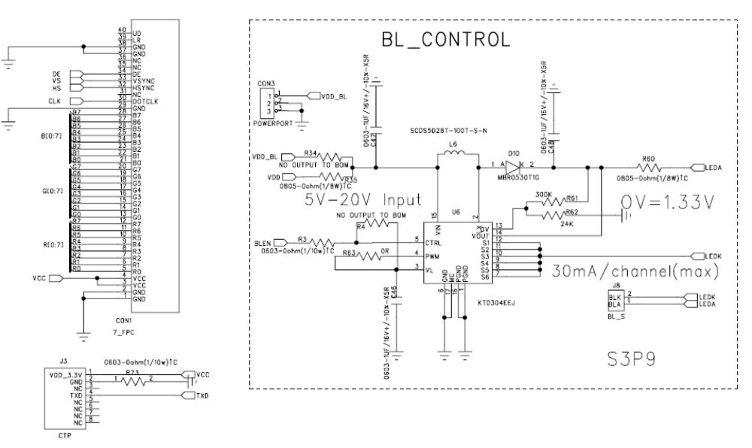

NOTES:
1 LED forward Voltage(Vf) = 9.6V typical, 9.0Vmin ,10.5Vmax.
2 Back-light LED Current(Ibl) = 180mA typical, 225mA max.

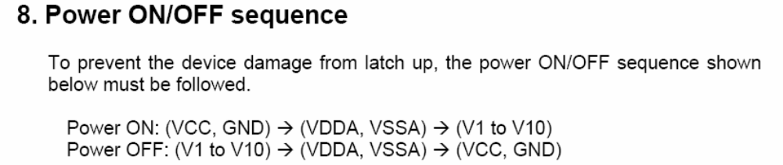
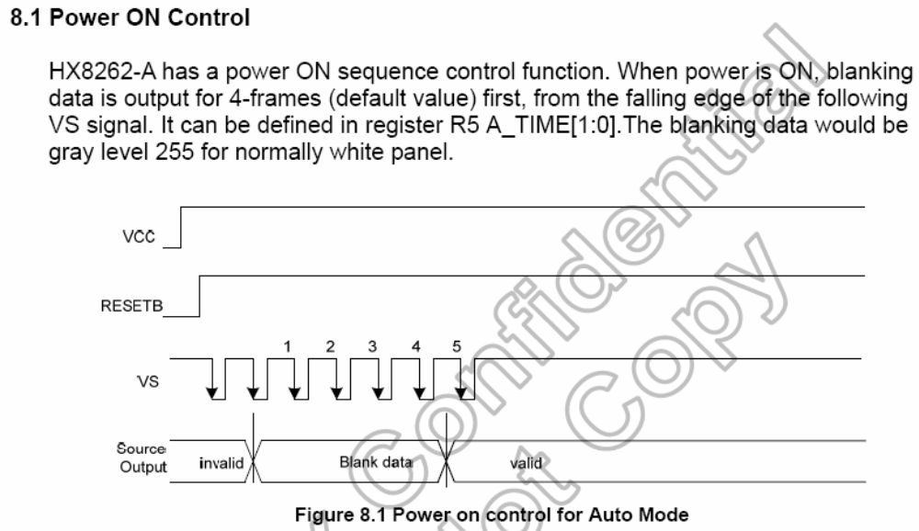
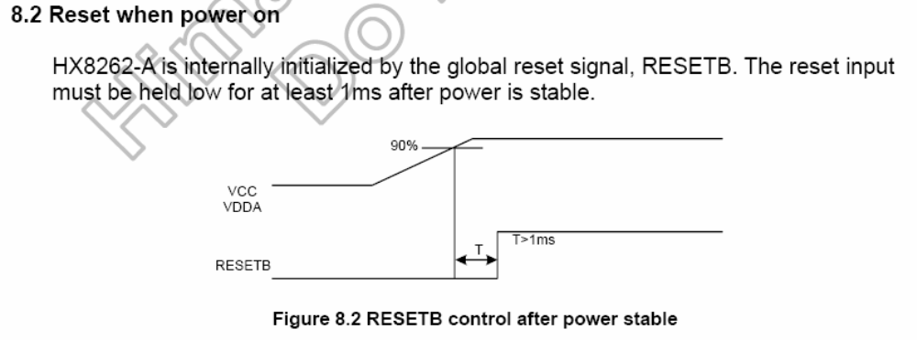
■ TIMING CHART
